AI-POWERED SALES REPORT AUTOMATION
Using SQL, Excel & AI-Generated Insights
Created by
Afifah Khatoon

Acknowledgment:
This project, “AI-Powered Sales Report Automation using SQL, Excel & AI,” was undertaken independently as part of my ongoing effort to build practical, job-ready skills in data analytics. It reflects my self-driven learning journey in SQL, Excel-based reporting, and applied use of AI tools for business insight generation.
I would like to acknowledge the open-source and public dataset community (Kaggle) for making quality datasets freely available for practice and portfolio-building. I am also grateful to my family and friends for their continuous support and encouragement throughout this journey.

Project Objective:
The objective of this project is to design and demonstrate an end-to-end, automated workflow for business report generation — combining SQL for data storage and querying, AI for automatic insight generation, and Excel/PowerPoint for professional presentation of results.
Specifically, this project aims to:
- Clean and structure raw sales data in Excel, then load it into a relational (SQL) database.
- Write SQL queries to extract key business metrics (revenue, profit, top products, regional performance, monthly trends).
- Use AI (Claude/ChatGPT) to automatically generate written summaries and business insights from the extracted data.
- Present the findings through an interactive Excel dashboard and a recruiter-ready PowerPoint deck.

Project Overview:
Organizations generate large volumes of transactional data every day, but converting that raw data into actionable business insight is often slow and manual. This project simulates a real-world business reporting workflow using a retail sales dataset (Superstore Sales, 9,994 records) sourced from Kaggle.
The raw dataset was first cleaned and standardized in Microsoft Excel (fixing inconsistent date formats, removing duplicates, and correcting data types) and then loaded into a SQL database using SQL Workbench. SQL queries were used to extract key performance indicators such as total sales, profit by region, top-performing products, and monthly sales trends.
The extracted results were then passed to an AI model to auto-generate plain-language business insights and recommendations — replicating how AI copilots are increasingly used in real analytics workflows. Finally, the cleaned data and insights were compiled into an interactive Excel report (with KPI cards and charts) and a concise PowerPoint deck suitable for stakeholder presentation.

Tools & Technologies Used:
Category | Tools
Database | MY SQL Workbench
Data Cleaning | Microsoft Excel
Query & Analysis | SQL (joins, aggregations, window functions)
AI Insight Generation | Claude / ChatGPT
Reporting | Microsoft Excel (dashboards, KPI cards)
Presentation | Microsoft PowerPoint

Scope of the Project:
This project focuses on retail/sales data but the same workflow — SQL extraction → AI-generated insights → Excel/PowerPoint reporting — can be applied to any business function, including HR analytics, inventory management, and financial reporting. It is designed to reflect practical, entry-level responsibilities relevant to a data-driven business environment.
Dataset Information:
Dataset Name: Superstore Sales Dataset
Dataset Link: https://github.com/afifahkhatoon61-beep/my-certificates-projects/blob/main/Superstore%20Sales%20Dataset.csv
- Records: 9,694 rows
- Columns: 21
- Source: Kaggle
- Time Period: 2014–17

Data Cleaning Process (Excel):

Imported the raw dataset (9,994 rows) into Microsoft Excel

Standardized inconsistent date formats (Order Date, Ship Date) into a single consistent format

Checked for and removed duplicate rows

Validated the dataset for missing values

Preserved the data type of columns like Postal Code (as text) to prevent loss of leading zeros

Prepared the final cleaned dataset for loading into the SQL database.

Cleaned Dataset Link: https://github.com/afifahkhatoon61-beep/my-certificates-projects/blob/12afdbabac34a1bfa045962e4abff65392b2c21f/cleaned%20dataset.xlsx

SQL-Based Data Analysis & Key Insights Extraction:
1.Data Import Verification:

Explanation: This query was used to confirm that the entire dataset was successfully imported into the SQL database. The result returned 9,994 rows, matching the original cleaned dataset exactly.

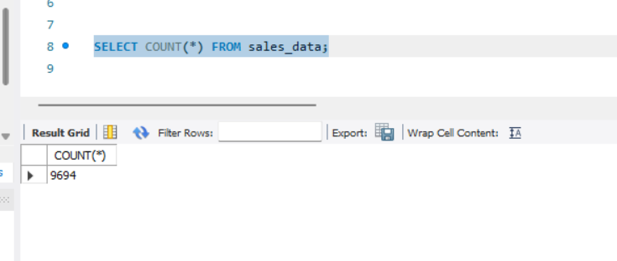

2.Region-Wise Sales & Profit Analysis:

Explanation: This query identifies how sales and profit are distributed across different regions. It helps determine which regions are the strongest revenue contributors and which ones may need business attention.

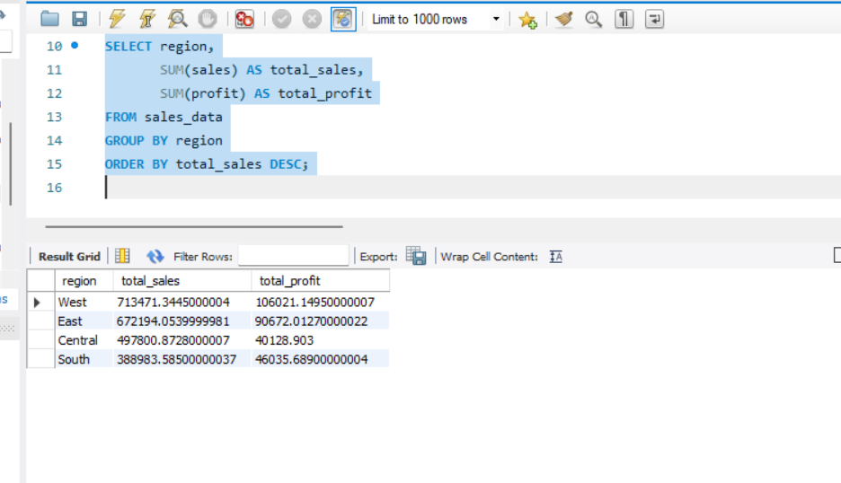

3.Top 10 Best-Selling Products:

Explanation: This query extracts the top 10 products generating the highest total sales. It highlights which products drive the most revenue for the business.

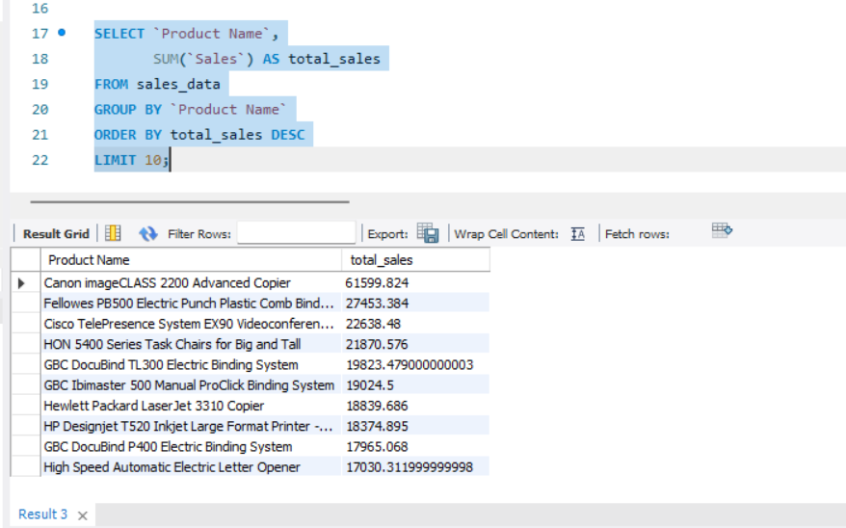

4.Monthly Sales Trend:

Explanation: This query aggregates sales by month to reveal seasonal patterns and trends over time. It's useful for identifying peak sales periods across the years.

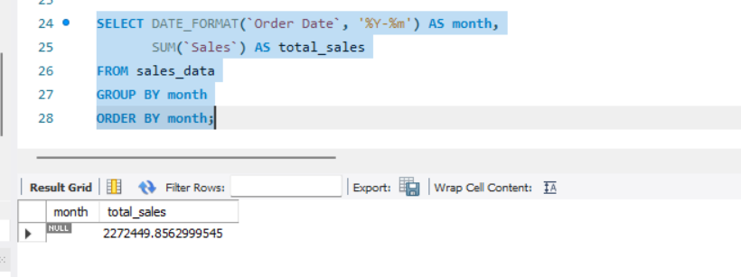

5.Category-Wise Profitability:

Explanation: This query compares profit margins across product categories, helping identify which categories are most and least profitable for the business.

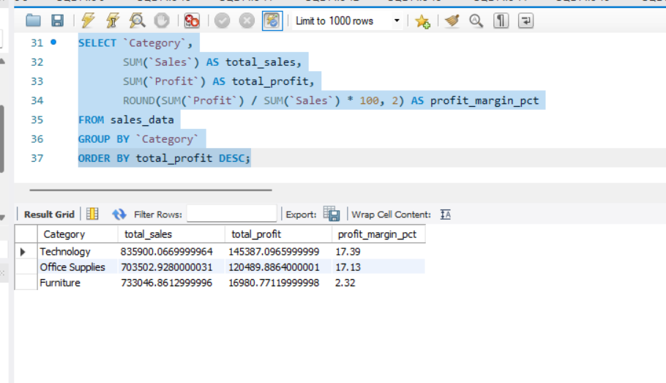

6.Loss-Making Sub-Categories:

Explanation: This query flags sub-categories with negative total profit, helping pinpoint underperforming product lines that may need pricing or discount strategy changes.

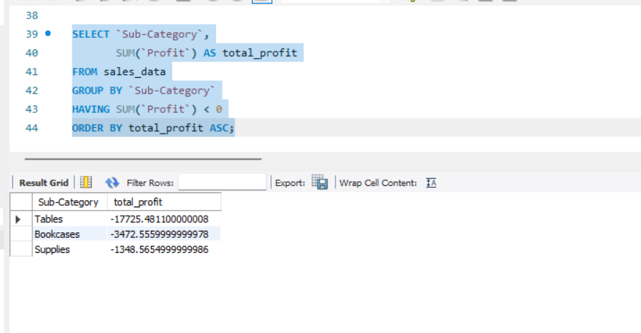

7.Product Ranking within Each Category (Window Function):

Explanation: This query uses the RANK() window function to rank products by sales within their own category — rather than across the whole dataset. This shows the top-performing product in every category, which is more business-relevant than a single overall top-10 list. It demonstrates advanced SQL skills like PARTITION BY and window functions, beyond basic aggregation.

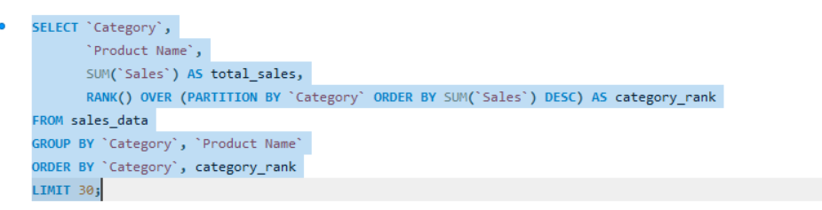
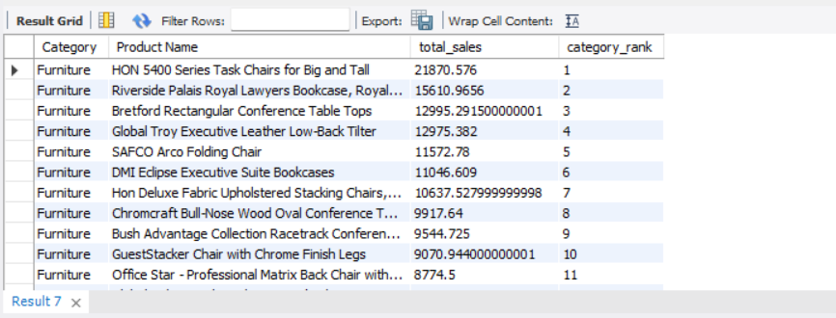

SQL Queries File Link: https://github.com/afifahkhatoon61-beep/my-certificates-projects/blob/main/sales%20sql%20analysis.sql

AI-Generated Business Insights:

Explanation: The results of the SQL queries above were passed to an AI model (Claude) to automatically generate business insights and recommendations in plain language — replicating how AI copilots are used in real analytics workflows to accelerate decision-making.

Generated Insights:

• West is the strongest region, generating $713K in sales and $106K profit (the highest of all regions), while Central lags behind with the lowest sales ($498K) despite being a large market — suggesting an opportunity to improve marketing or pricing strategy there.

• Technology is the most profitable category (17.4% margin), closely followed by Office Supplies (17.1%), but Furniture drags overall profitability down — despite generating $733K in sales, it returns only 2.32% margin, indicating heavy discounting or high shipping/production costs.

• Tables are actively losing money (-$17,725 profit) and are the single biggest drag on Furniture's poor performance. Bookcases (-$3,473) and Supplies (-$1,349) are also unprofitable. Recommendation: review discount policy on Tables specifically.

• Copiers and binding machines dominate top sales, not everyday office items — the Canon imageCLASS 2200 Copier alone generated $61.6K, nearly 2.2x the next highest product.

• Sales peaked in November 2017 ($118K, the highest single month in the dataset), consistent with a Q4/holiday seasonal pattern — useful for inventory and staffing planning in future years.

• Overall business health: $2.27M total sales, $286K total profit, 12.6% overall margin — healthy, but pulled down significantly by the Furniture category's losses.

Interactive Excel Dashboard:

Explanation: An interactive Excel dashboard was built using formulas linked directly to the cleaned dataset, displaying key performance indicators (Total Sales, Total Profit, Profit Margin, Total Orders) alongside a loss-making sub-categories alert. All values update automatically if the underlying data changes, making the report reusable and audit-ready.

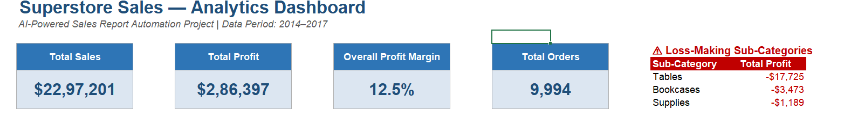

Visual: Region-wise Sales & Profit:

Explanation: This chart compares total sales and profit across all four regions. West and East are the strongest-performing regions in both sales and profit, while Central generates the lowest sales despite being a major market, highlighting a potential area for regional strategy improvement.

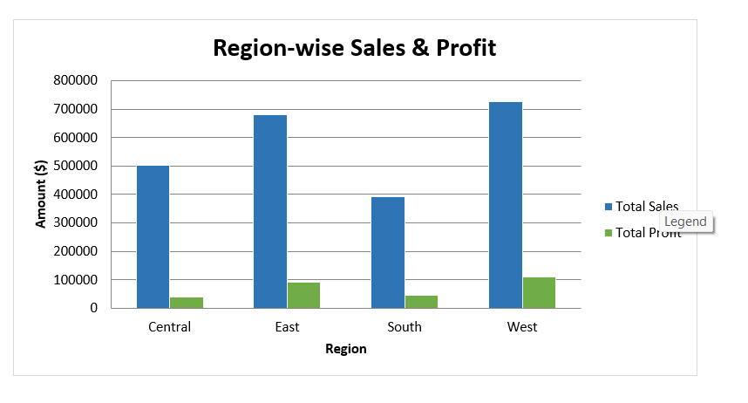

Category-wise Profit Margin Analysis:

Explanation: This chart shows profit margin percentage across the three product categories. Technology and Office Supplies both maintain healthy margins (~17%), while Furniture lags significantly at just 2.5%, indicating pricing or discounting issues that are dragging down overall profitability.
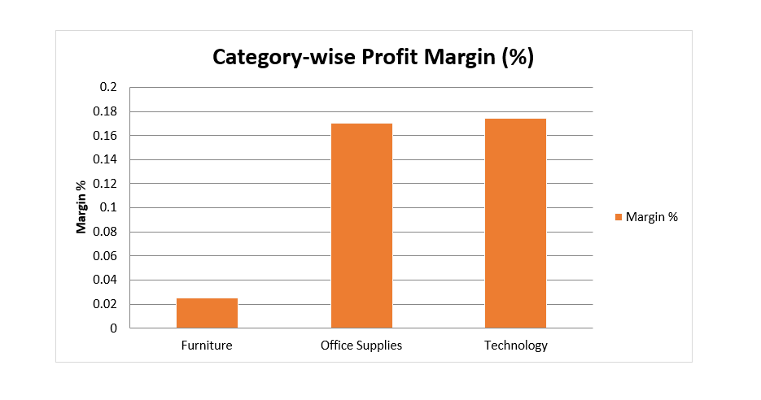

Monthly Sales Trend (2014–2017):

Explanation: This chart tracks total sales month-by-month across four years, showing a strong seasonal, cyclical pattern with a repeated year-end spike. Sales peaked in November 2017 ($118K), the highest point in the dataset, indicating consistent Q4/holiday-driven demand useful for future inventory and staffing planning.

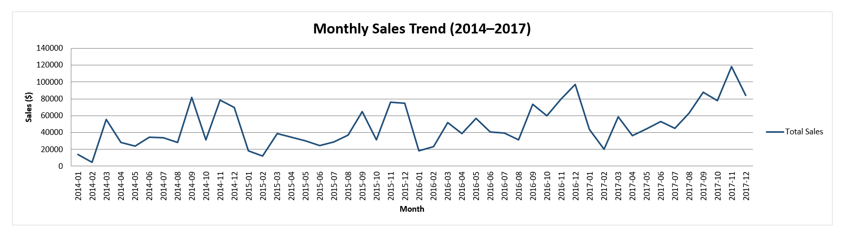

Top 10 Best-Selling Products:

Explanation: This chart ranks the top 10 individual products by total sales. The Canon imageCLASS 2200 Advanced Copier leads by a wide margin ($61.6K), nearly 2.5x the next highest product, showing that high-value equipment (copiers, binding machines) drives more revenue than everyday office supplies.

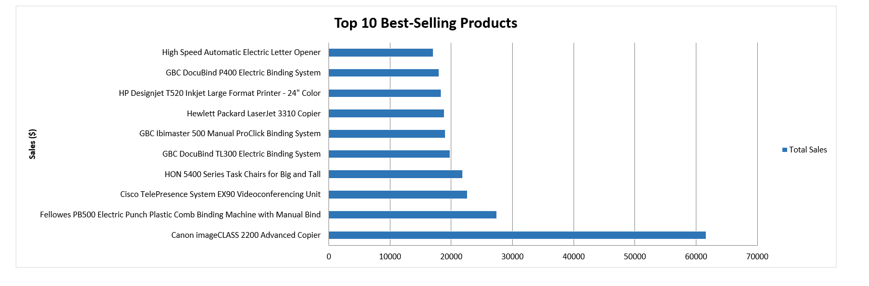

Excel Dashboard Link: https://github.com/afifahkhatoon61-beep/my-certificates-projects/blob/8547d64ceb9f37109e0ad5a8b2b74a9c7338b721/Sales_Analytics_Dashboard.xlsx

PowerPoint Presentation:
Sales_Report_Automation.pptx:

Explanation:
- A 10-slide PowerPoint presentation was created to summarize the entire project in a recruiter/stakeholder-friendly format
- Covers the problem statement, objective, end-to-end workflow, tools used, and dataset overview
- Presents SQL analysis highlights along with native, editable charts (region-wise performance, category margins, monthly trends, top products)
- Includes AI-generated business insights and clear, actionable recommendations
- Designed to be presented directly in interviews to demonstrate both technical skills and business communication ability

PowerPoint Presentation Link:

https://github.com/afifahkhatoon61-beep/my-certificates-projects/blob/main/Sales_Report_Automation.pptx

Conclusion:
Through this project, a complete data analytics automation pipeline was built and demonstrated — from raw data cleaning to AI-assisted insight generation to stakeholder-ready reporting. It highlights practical, job-relevant skills in SQL, Excel automation, and applied use of AI tools in a business analytics context.

THANK YOU,

